Problem A1:

1. Gerschgorin’s here tells us that eigenvalues of A must either satisfy |lamda – 2| <= 1 (the sum of the absolute-values of the off-diagonals in the first/last row is 1 and the diagonal is 2), |lambda – 2| <= 2 (the sum of the absolute-values of the off-diagonals in the rest of the rows is 2). So the eigenvalues are either in the interval [1, 3] or [0, 4], as our matrix is real and symmetric it must have only real eigenvalues.
2. 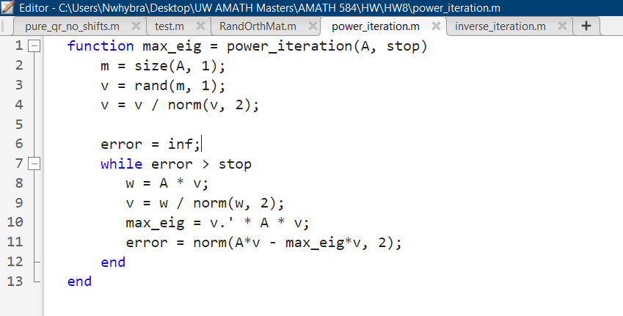
3. 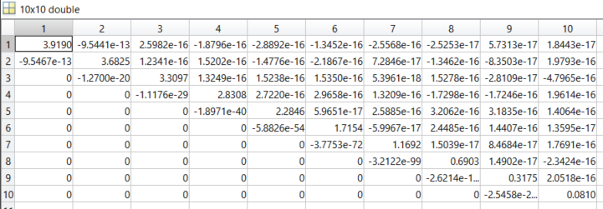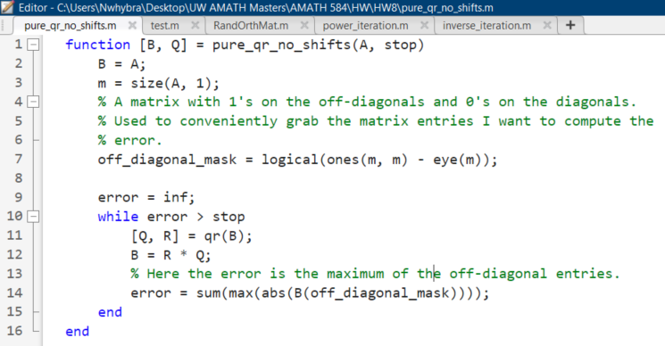
4. 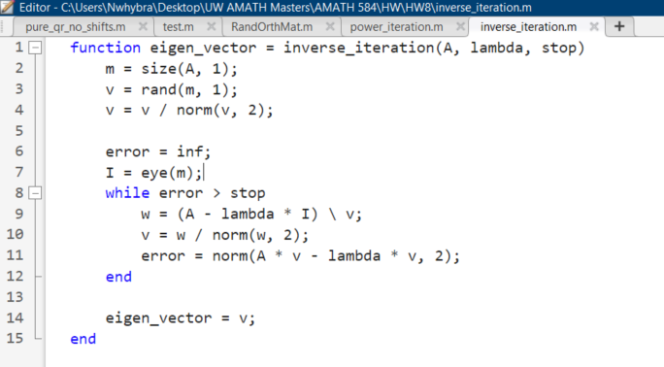

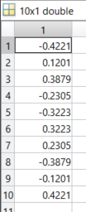

Full test script:

